*Florida International University*

*School of Computing and Information Sciences*

CIS 4911 - Senior Capstone Project

Software Engineering Focus

Feature Document

User Story #678

**Team Member:**

Andrew Mitchell

**Product Owner(s)**:

Francisco R. Ortega

**Mentor(s)**:

Francisco R. Ortega

...

**Instructor**: Masoud Sadjadi

**User Story -** Implement Override Mode

* As a User I would like to enable or disable certain devices and their modes so I can experience the program using devices in different ways and find which way suits me best.

Acceptance Criteria

* Enable ‘Override Mode’ button that enables you to switch certain functionality on and off for different devices.
* Must work for multitouch
* Must work for leap (Gestures and drawing)
* Must work for EyeX

**Use Case**

Use Case

Enable override mode to disable and enable certain devices and their functionality at will.

Details:

Actor: User

Pre-conditions:

Multitouch must be running.

Description:

Use case begins when the user touches the ‘device modes’ button. The user then pulls up a menu in which they can toggle the devices on (green box) and off (box color of the background).

Post-conditions:

After selecting a specific box, that device must be ‘off’ in the context of our program.

(Currently multitouch will still enable you to check if you want to turn devices on and off since that is the only available method).

Decision Support:

Frequency: Often. Currently it is the easiest way to see which devices you are using. In addition you can implement your own ‘Modes’.

Criticality: High. Since the program is for learning about how users can interact with multiple devices, controlling which device functionality we are working with is a huge plus!

Risk: Medium. Slight code restructure (ensure device handler is working properly).

Reliability: Highly.

Mean time to Failure –  Almost never. It should only ‘fail’ when the user misses the button.

Availability –Available when Multitouch is enabled. Buttons can only toggle on device functionality if the device is plugged in!

Performance:

N/a

Supportability:

Acer Multitouch.

Leap Motion.

Tobii EyeX Camera.

Modification History:

Owner: Andrew Mitchell

Initiation date: 3/30/2016

Date last modified: 4/3/2016

**Use Case Diagram**

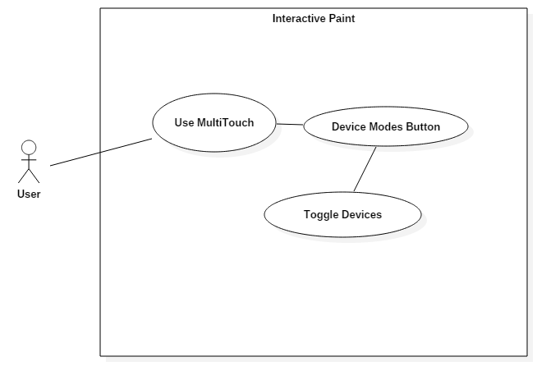

**Sequence Diagram**

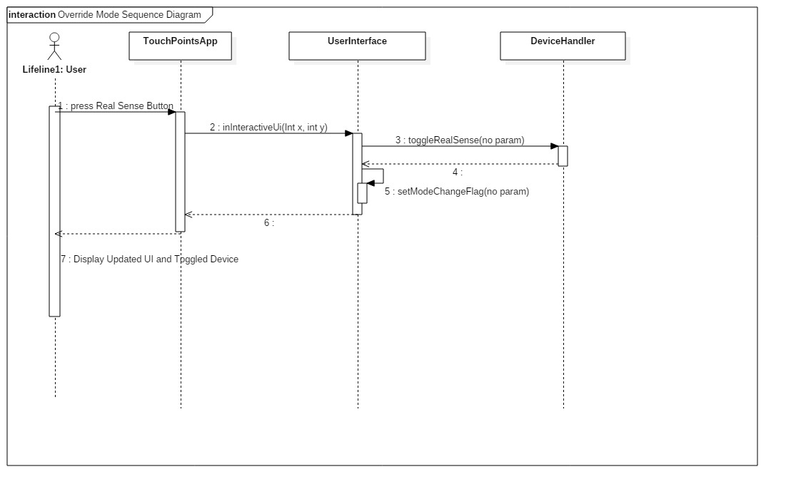

The Sequence of Events for all the device toggles are the same. Here is the run through for the sequence when toggling the Real Sense device on or off.

**Class Diagram**

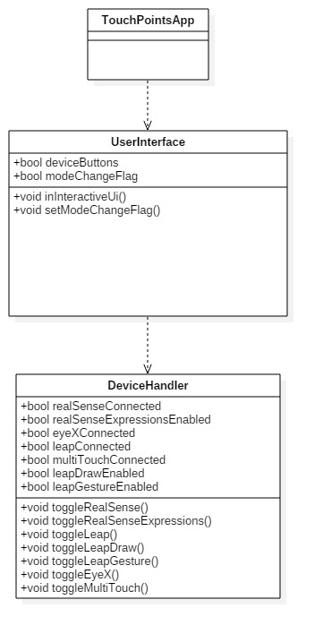

**Unit Test**

Sunny Day:

Test Case: Toggle multitouch

Test Purpose:

Ensure that touching the multitouch device override device button correctly turns off the multitouch functionality as well as turns on (if the device is actually plugged in).

Test Setup:

1. Have multitouch plugged in
2. Press the ‘Device Modes’ button in the mode box
3. Press the ‘Multitouch’ button (toggles it off)
4. Try to draw
5. Try double tap gesture
6. Try to select buttons on the top right (Colors, shapes)
7. Press the ‘Multitouch’ button (toggle it on)
8. Try to draw
9. Try to select buttons on top right.
10. Try double tap gesture.

Test Output:

After toggling multitouch off the user could not draw or touch any buttons, nor could they do the double tap gesture. Once they toggle the button back on, the user successfully drew. They could select the color button and change color. They could ‘double tap’ to pull up radial menu.

Expected Output:

When the multitouch is ‘off’ you cannot draw with the multitouch, cannot select any UI elements (except the Device Modes buttons), canot do a multitouch gesture.

When the multitouch is on you can draw with the multitouch, can select top right button, and can perform multitouch gestures.

Test Case: Toggle Leap Motion

Test Purpose:

Ensure that disabling leap motion turns off both leap draw and leap gesture (device no longer performs any actions). While turning it on (while device is connected) will allow you to use the enabled functions.

Test Setup:

1. Open Device Mode menu
2. Make sure leap motion is toggled on
3. Toggle on Leap Draw
4. Draw with leap motion
5. Toggle on Leap Gesture
6. Swipe gesture with leap motion
7. Toggle off Leap motion
8. Try to draw with leap motion
9. Try to do a swipe gesture with leap motion

Test Output:

The first draw with leap motion successfully drew.

The first swipe gesture successfully read and changed colors

After toggling off Leap Motion

The next draw attempt failed.

The new gesture attempt failed.

Expected Output:

When the leap motion is on, it should be able to perform any leap motion functionality that is also on.

* If Leap Motion and Leap Gesture is on it should detect leap gesture
* If leap motion and leap draw is on it should be able to draw
* If leap motion is off and leap draw is on it will NOT draw
* If leap motion is off and leap gesture is on it will NOT detect gestures

Test Case: Toggle Leap Draw

Test Purpose:

Ensure that the leap draw button turns on and off leap draw functionality

Test Setup:

1. Open Device Modes menu
2. Ensure Leap motion is on.
3. Toggle on Leap Draw
4. Attempt to draw with leap draw
5. Toggle off leap draw
6. Attempt to draw with leap
7. Toggle on leap draw
8. Attempt to draw with leap draw

Test Output:

Step 4: Draw was successful

Step 6: Could not draw with leap motion

Step 8: Could successfully draw with leap motion.

Expected Output:

When leap motion and leap draw are on the user should be able to draw with the leap device. When leap motion is on and leap draw is disabled, they should not be able to draw with the leap motion.

Test Case: Toggle Leap Gesture

Test Purpose:

Test Setup:

1. Open Device Modes menu
2. Ensure Leap motion is on.
3. Toggle on Leap Gesture
4. Attempt to do a swipe gesture
5. Toggle off leap gesture
6. Attempt to do a swipe gesture
7. Toggle on leap gesture
8. Attempt to do a swipe gesture

Test Output:

Step 4: Changed color with leap swipe gesture

Step 6: Could not perform a swipe gesture

Step 8: Could successfully perform a swipe gesture.

Expected Output:

When leap motion is on and leap gesture is on, the user can perform leap motion gestures. When leap gesture is off, the program will not detect any leap gestures.

Test Case: Toggle EyeX

Test Purpose:

Make sure the EyeX ‘Menu Grab’ functionality is turned off when eyeX is enabled and is off when EyeX is disabled.

Test Setup:

1. Pull up Device Modes menu
2. Toggle EyeX off
3. Toggle EyeX on
4. Look to the top right corner of the screen
5. Look to the bottom right corner of the screen
6. Toggle EyeX Off

Test Output:

After toggling off EyeX the menus were pulled up.

After eyeX was toggled on, the menus disappeared.

After Looking at the top right the buttons came up

After Looking at the bottom right the mode box came up

Expected Output:

When EyeX is on, the UI gets pulled up only when looking at those UI elements (Top left for mode buttons, bottom right for mode box).

When EyeX is disabled the UI elements should always be available.

Rainy Day Tests:

Test Case: Toggle Disconnected Devices.

Test Purpose:

Make sure you cannot ‘enable’ a device when it is not connected.

Test Setup:

1. Start the program with only multitouch plugged in
2. Toggle the Device Modes menu
3. Tap Leap Motion Button
4. Tap Leap Draw button
5. Tap Leap Gesture button
6. Tap EyeX button

Test Output:

* After tapping the leap motion button the box stayed black
* After tapping the leap draw button the box turned green
* After tapping the leap gesture button the box turned green
* After tapping the EyeX button the box stayed black

Expected Output:

You cannot enable a device that is not plugged in. Only leap draw and Leap Gesture should get a green box (functionality is on, but cannot be performed since leap motion is not ‘on’), while EyeX and Leap Motion will not turn on (Black Box)

**Integration Test**

The Device Modes buttons currently work with all implemented devices (excluding real sense which is in development this sprint).

Toggling on and off devices still leaves the functionality intact.

After toggling on, then off, then on the multitouch you can still interact with all its UI elements, as well as draw with all shapes and colors.

After toggling on, then off, then on the leap motion device and leap draw, all the gestures and drawing capabilities remain intact.

**User Guide**

Press the ‘Device Modes’ button in the ‘Mode’ box. This will pull up a menu where you can enable or disable any given device and their functionality by pressing their respective buttons.

To access the ‘override’ modes functionality you must first click the ‘Device Modes’ button located on the top right corner of the mode box displayed in this image.

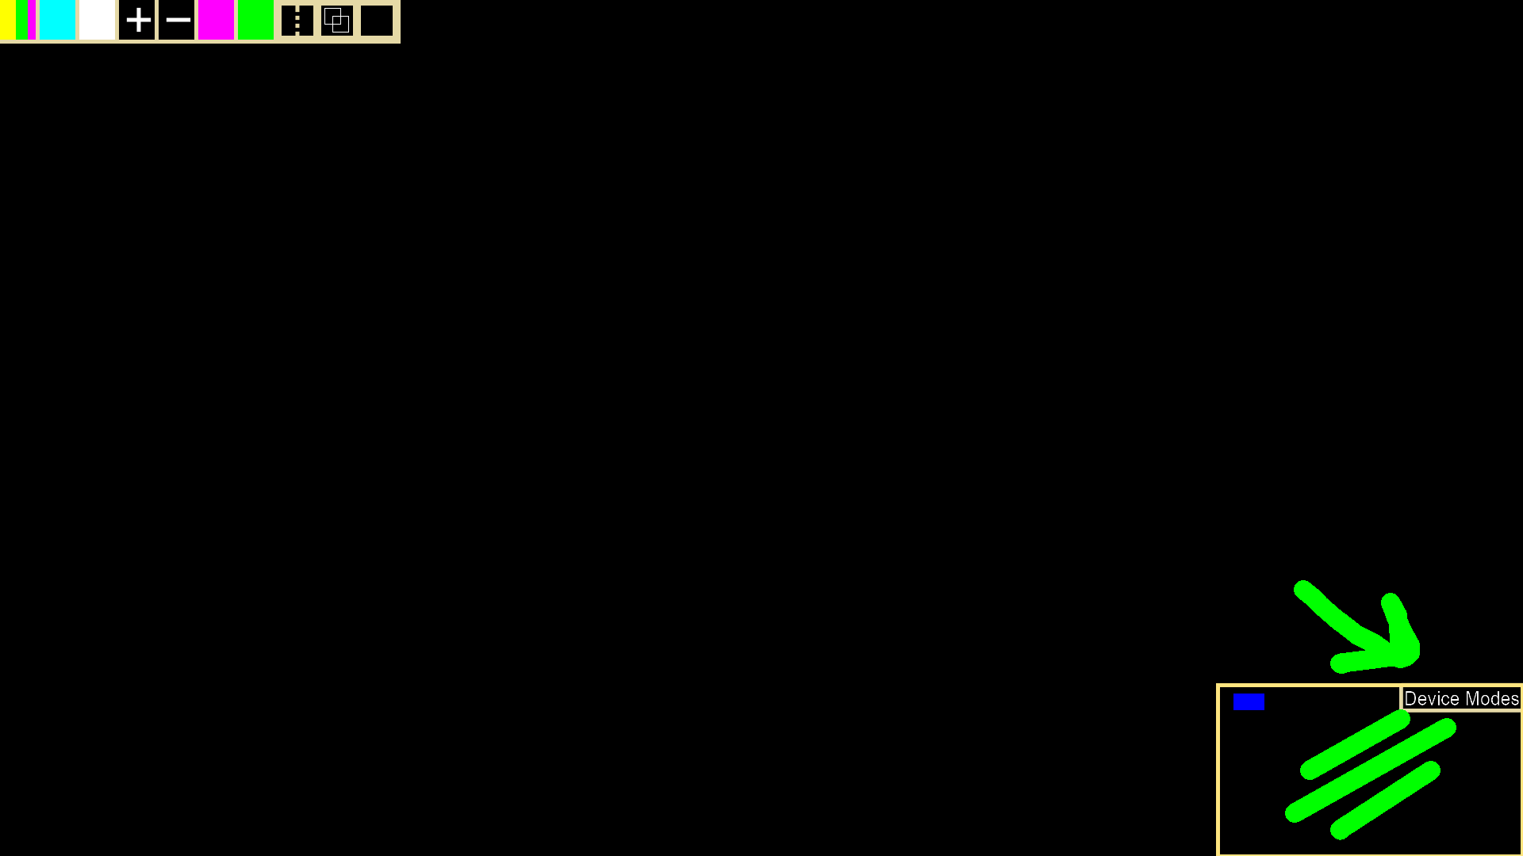

After pulling up the mode box you can toggle on and off certain devices using the Leap Motion button, the EyeX button, and the Multitouch Button. As well as specific functionality for the leap motion device using Leap Draw and the Leap Gesture Buttons. A green box indicates that the device or functionality is currently active (See Multitouch button) while the blacked out box means that the device or functionality is currently off.

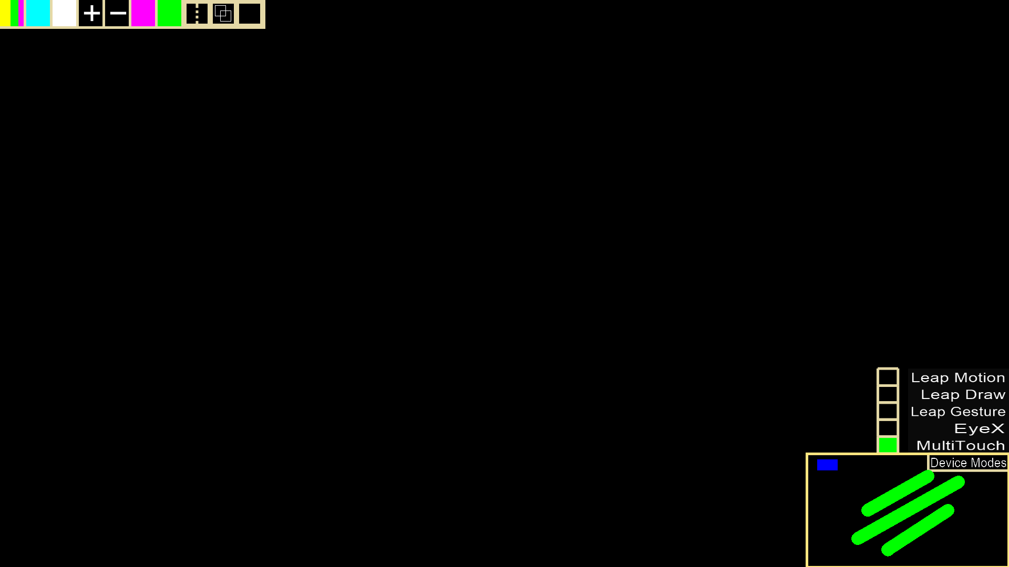

**Glossary**

Device Modes – These modes help display and show you which devices are available and which functionality they will provide.

**Devices -**

Leap Motion

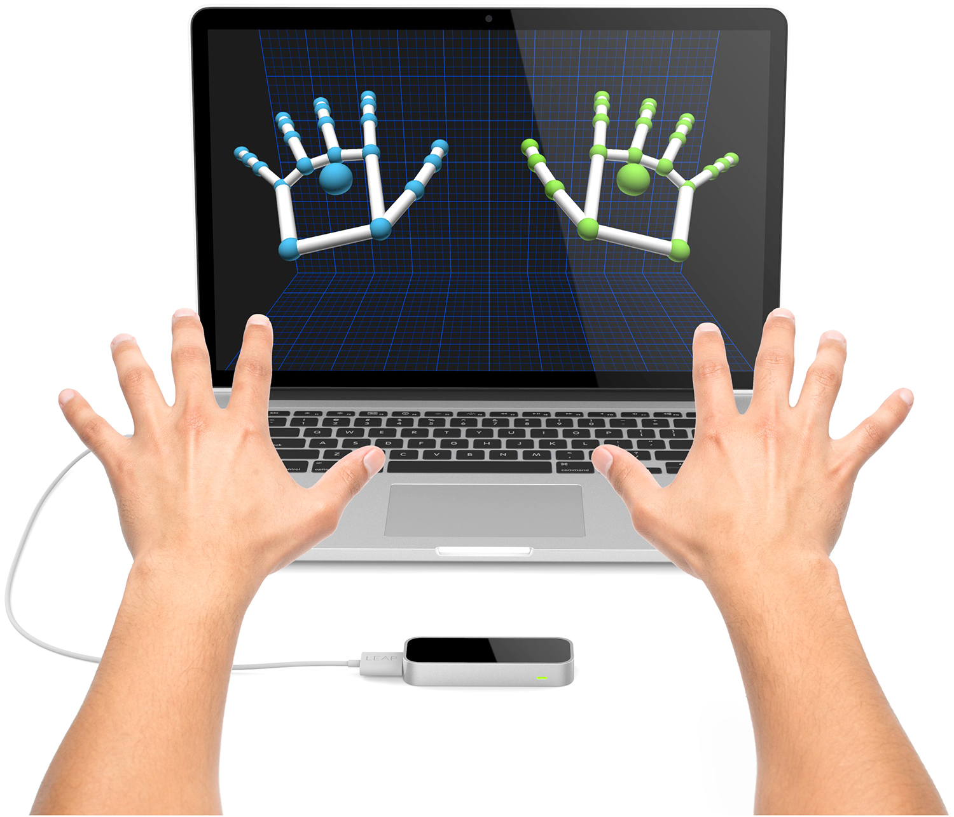

Acer MultiTouch

